**Raspunsuri grile:**

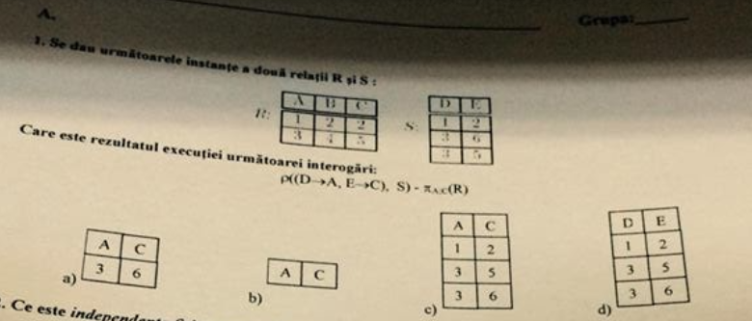

***Se dau urmatoarele instante a doua relatii R si S:***

Raspuns: a)

-----------------------------------------------------------------------------------------------------------------

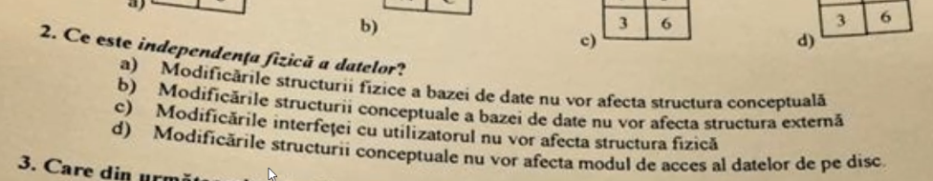

***independenta fizica a datelor:***

Raspuns: a) modificarile structurii fizice a bazei de date nu vor afecta structura conceptuala

-----------------------------------------------------------------------------------------------------------------

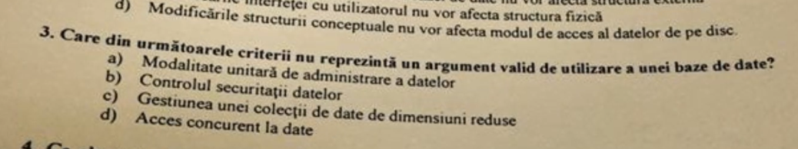

***3. Care din urmatoarele criterii nu reprezinta un argument valid de utilizare a unei baze de date?***

Raspuns: c) Gestiunea unei colectii de date de dimensiuni reduse

-----------------------------------------------------------------------------------------------------------------

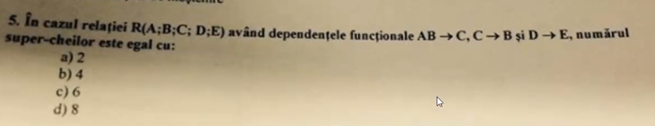

***5. super cheie:***

**Raspuns: 6** (?)

chei candidat: abd, acd

**super chei:**

abd: abdc, abde, abdce

acd: acde

---------------------------------------------------------------------------------------------------------------------------

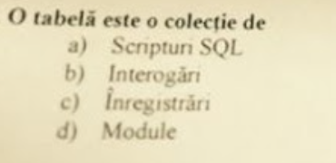

***4. O tabela este o colectie de:***

Raspuns: c) Inregistrari

-----------------------------------------------------------------------------------------------------------------------

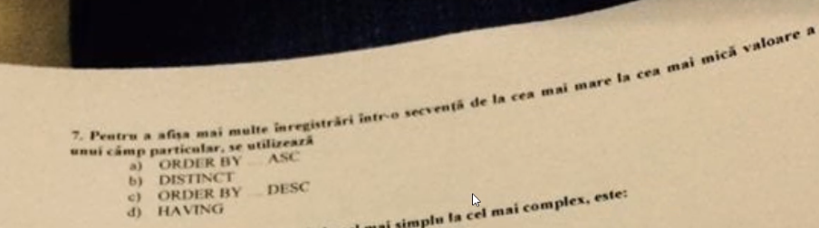

***5. Pentru a afisa mai multe inregistrari intr-o secventa de la cea mai mare la cea mica valoare a unui camp particular, se utilizeaza:***

Raspuns: c) ORDER BY _ DESC

---------------------------------------------------------------------------------------------------------------------------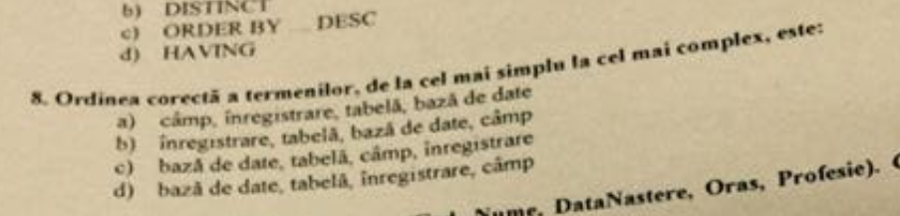

***6. Ordinea corecta a termenilor, de la cel mai simplu la cel mai complex este:***

Raspuns: a) camp, inregistrare, tabela, baza de date

----------------------------------------------------------------------------------------------------------------

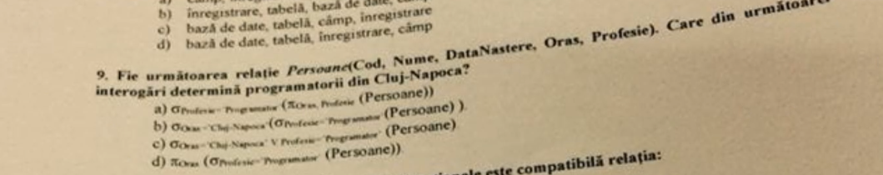

***7. Algebra relationala (dependente functionale este compatibila):***

Raspuns: b)

daca la c) era SI era bun

---------------------------------------------------------------------------------------------------------------------------

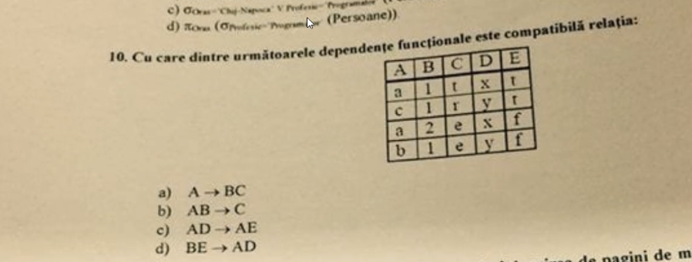

***8. Dependente functionale:***

Raspuns: b)

---------------------------------------------------------------------------------------------------------------------------

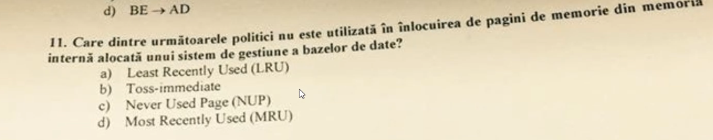

***11. inlocuirea de pagini de memorie in memoria interna alocata unui sistem de gestiune:***

Raspuns: c) NUP

---------------------------------------------------------------------------------------------------------------------------

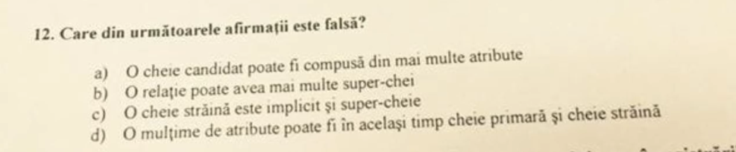

***Afirmatie Falsa***

Raspuns: c) O cheie straina este implict si super-cheie

-----------------------------------------------------------------------------------------------------------------------

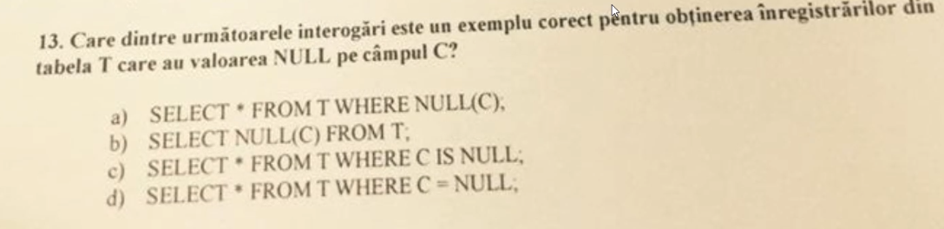

Raspuns: c) SELECT * FROM T WHERE C IS NULL **(NULL = NULL DA FALSE)!!!!**

--------------------------------------------------------------------------------------------------------------------------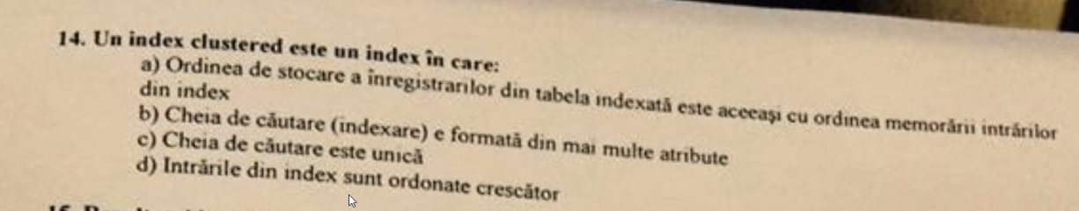

***index clustered:***

Raspuns: a) Ordinea de stocare a inregistrarilor din tabela indexata este aceeasi cu ordinea memorarii intrarilor din index.

--------------------------------------------------------------------------------------------------------------------------

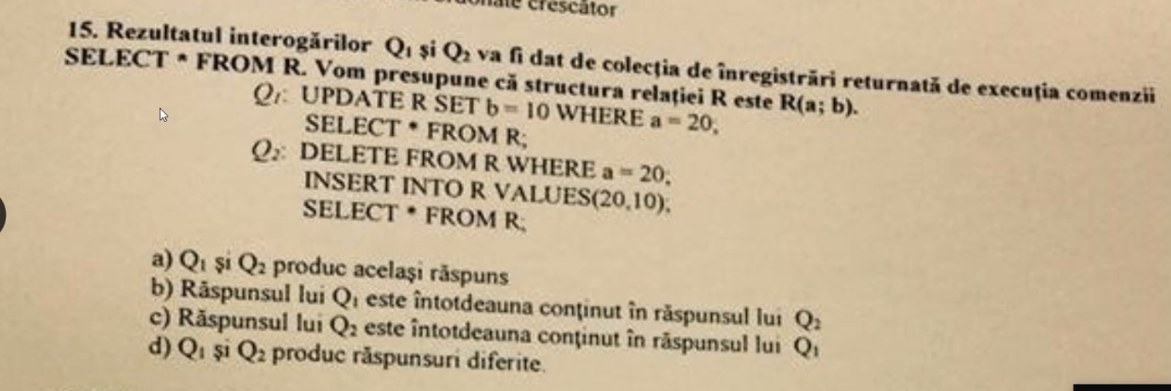

***15. Q1 si Q2: (update si delete)***

Raspuns: b) Q1 este continut in Q2

--------------------------------------------------------------------------------------------------------------------------

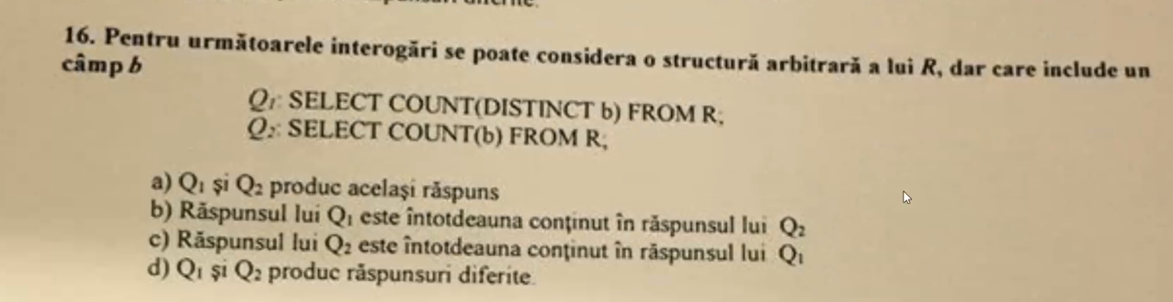

***16. Q1 si Q2 - count***

Raspuns: *b) Q1 inclus in Q2*

**--------------------------------------------------------------------------------------------------------------**

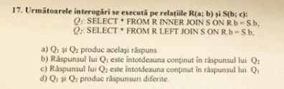

***17. Q1 si Q2 (inner join si left join):***

Raspuns: b) Q1 inclus in Q2

**-------------------------------------------------------------------------------------------------------------**

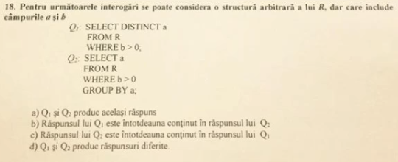

***18. Q1 si Q2 (distinct si group by):***

Raspuns: a) la fel

!!!!!!!! **distinct** si **group by** iau in considerare **null**.

----------------------------------------------------------------------------------------------------------------

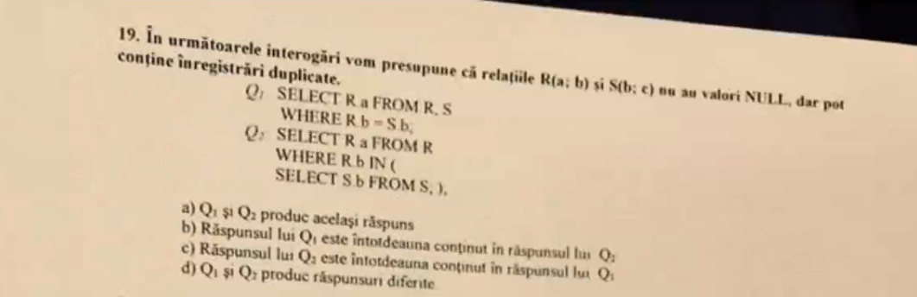

***19. Q1 si Q2 (where si in):***

Raspuns: c) Q2 continut in Q1

Where le verifica pe toate, pe cand IN dupa ce a gasit primul match returneaza valoarea

------------------------------------------------------------------------------------------------------------------------

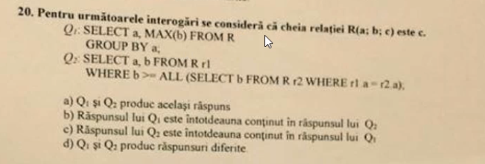

***20. Q1 si Q2 (max, group by si all):***

Raspuns: a) acelasi raspuns

---------------------------------------------------------------------------------------------------------------------------

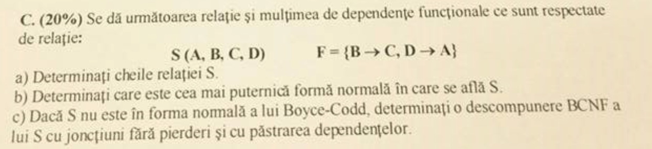

***Se da urmatoarea relatie si multimea de dependente funcitonale:***

1. Cheile: B,D
2. 1NF
3. 1.B->C nu respecta BCNF

Descompunem in {BDA} ,{BC}

2.D->A nu respecta BCNF

Descompunem R in {BD}, {BC},{DA}\

def : daca avem dependenta A - > B => R-B, AB

SUBIECT 5

---------------------------------------------------------------------------------------------------------------------------

1. Este posibil ca valoarea unei chei straine sa fie ***NULL***? Raspuns: C

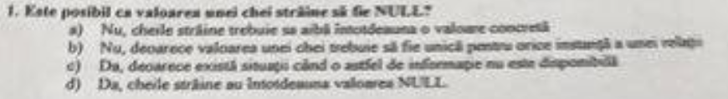

---------------------------------------------------------------------------------------------------------------------------

1. Ce este ***independenta logica*** a datelor? Raspuns: B (structura externa)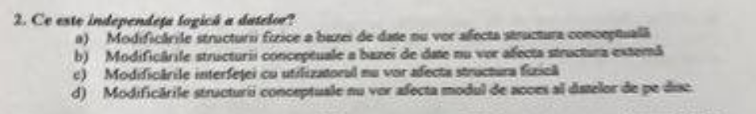

-----------------------------------------------------------------------------------------------------------------

1. Care din urmatoarele criterii **NU** reprezinta un argument valid de utilizare a unei baze de date? Raspuns: B (reprezentarea grafica a informatiilor)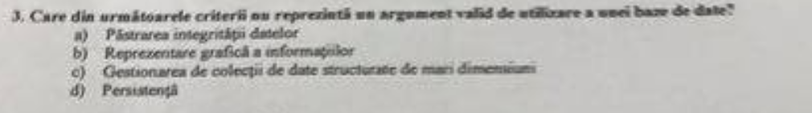

-----------------------------------------------------------------------------------------------------------------

1. Un index clustered este un index in care. Raspuns: A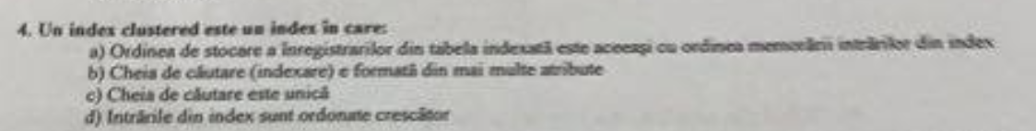

-----------------------------------------------------------------------------------------------------------------

1. Care dintre urmatoarele exemple **NU** reprezinta o alternativa de memorare a unei intrari dintr-un fisier index? Raspuns: B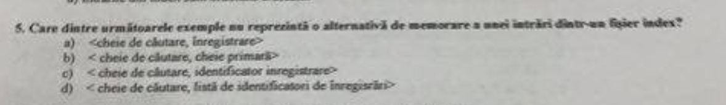

--------------------------------------------------------------------------------------------------------

1. Ordinea corecta a termenilor, de la cel mai complex, la cel mai simplu, este. Raspuns: D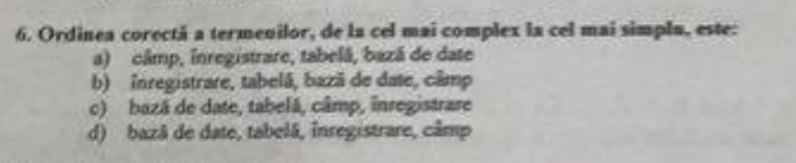

-----------------------------------------------------------------------------------------------------------------

1. Scopul unei tabele este de a: Raspuns: C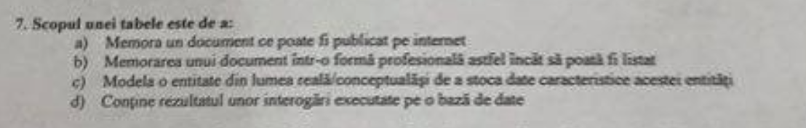

----------------------------------------------------------------------------------------------------------------

1. Pentru a afisa mai multe inregistrari intr-o secventa de la cea mai mare la cea mai mica valoare a unui camp particular, se utilizeaza: Raspuns: C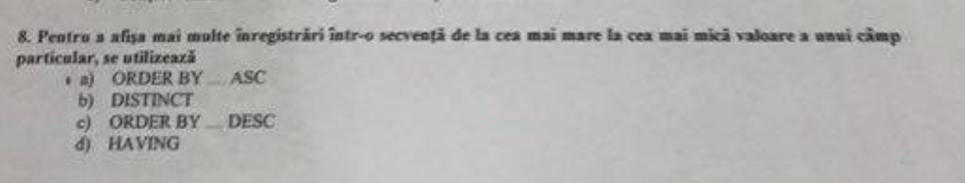

-----------------------------------------------------------------------------------------------------------------

1. Care dintre urmatoarele **NU** este o alternativa de translatare a unei relatii de mostenire intre doua clase A (super-clasa) si B (sub-lcasa) in tabelele unui model relational? Raspuns: B 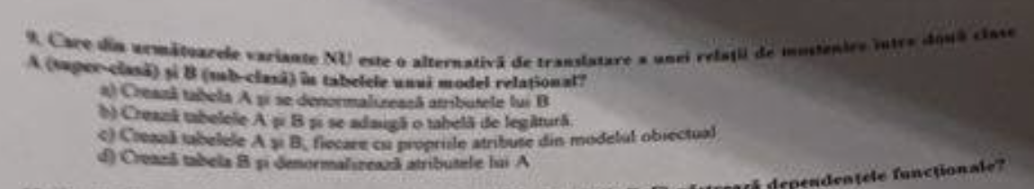

---------------------------------------------------------------------------------------------------------------------------

1. Descompuneri ale relatiei 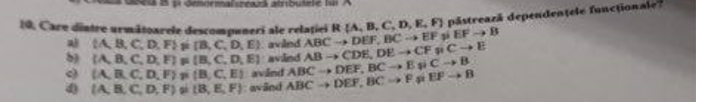

Raspuns:C

----------------------------------------------------------------------------------------------------------------------------

1. 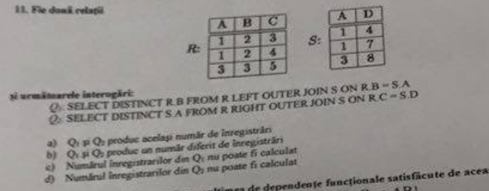

Raspuns:a)Q1 si Q2 produc acelasi numar de inregistrari

-----------------------------------------------------------------------------------------------------------------

1. 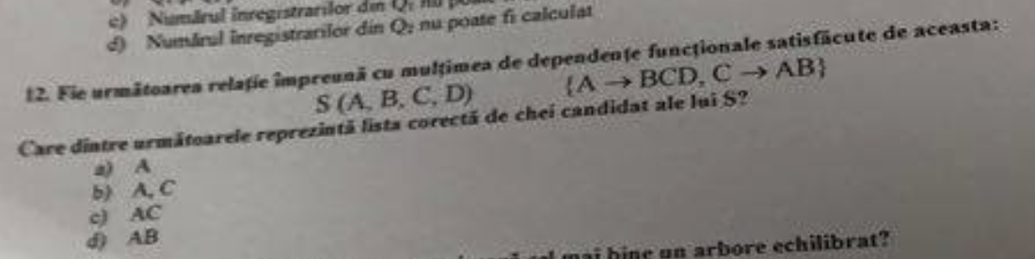Raspuns: B - chei candidat

---------------------------------------------------------------------------------------------------------------------------

1. Care dintre urmatoarele afirmatii caracterizeaza cel mai bine un arbore echilibrat? Raspuns: C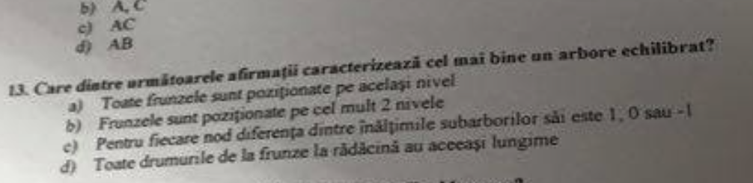

-----------------------------------------------------------------------------------------------------------------

1. Care este principala responsabilitate a unui Buffer Manager? Raspuns: B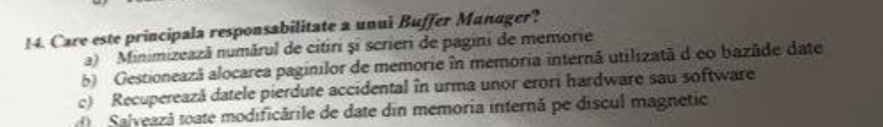

-----------------------------------------------------------------------------------------------------------------

1. Q1 si Q2

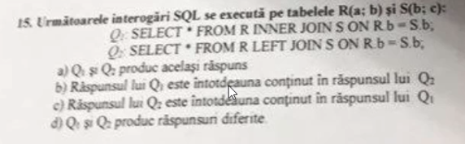

Raspuns: b) Q1 inclus in Q2

-----------------------------------------------------------------------------------------------------------------

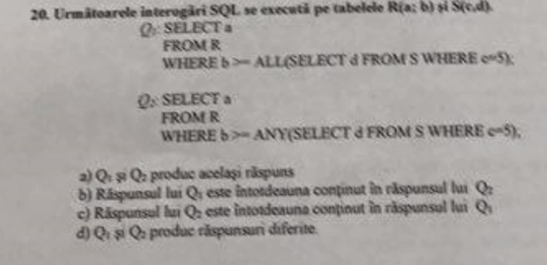

Q1 si Q2

The ANY operator returns true if any of the subquery values meet the condition.

The ALL operator returns true if all of the subquery values meet the condition.

Raspuns: b) Q1 inclus in Q2

-----------------------------------------------------------------------------------------------------------------

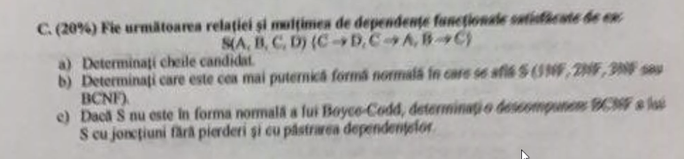

S(A,B,C,D) {C->D, C->A, B->C}

1. cheie candidat: B

supercheie: B,

BA, BC, BD,

BAC, BAD, BCD,

BACD

1. e in 2NF

2NF toata cheia trebuie sa fie conectata cu un atribut NEPRIMAR, e permisa tranzitivitatea

3NF poti deduce tot din cheie, NU e permisa tranzitivitatea

A depinde tranzitiv de B prin C

Atribut PRIM - atributele care fac parte din cheie

1. C->D nu respecta BCNF

Descompunem in {CAB}, {CD}

C->A nu respecta BCNF

Descompunem in {CB} {CD} {CA}

-----------------------------------------------------------------------------------------------------------------

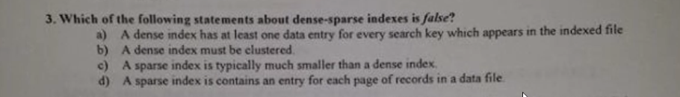

index dens si rar (un index dens poate fi si clustered si nonclustered, un index rar trebuie sa fie musai clustered)

Raspuns: b)

-----------------------------------------------------------------------------------------------------------------

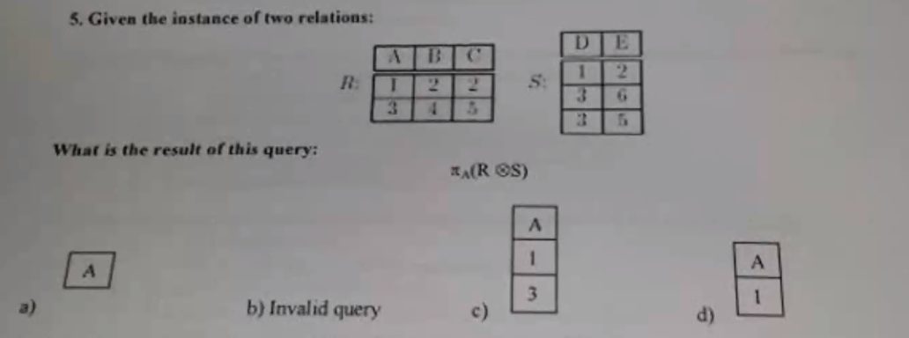

Raspuns: B) invalid

-----------------------------------------------------------------------------------------------------------------

x) AB -> C, ABC -> D, AC -> B

chei candidat: AB, AC

2 NF pentru ca din cheie ajungi la TOATE :) (prin tranzitivitate)

NU e in 3NF pentru ca implica tranzitivatea si nu ar trebui

-----------------------------------------------------------------------------------------------------------------

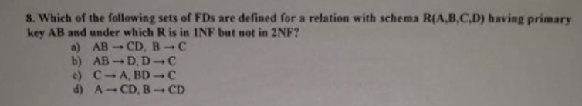

1NF, 2NF

Raspuns: a)

-------------------------------------------------------------------------------------------------------

**AB -> CD NU este echivalent cu A -> CD si B -> CD**

AB -> CD este echivalent cu AB->C si AB -> D

--------------------------------------------------------------------------------------------------------

trivial : AB -> A

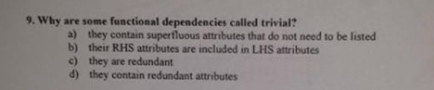

Raspuns: b)

-----------------------------------------------------------------------------------------------------------------

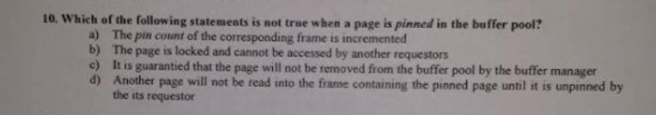

pin count

Rapsuns: b)

-----------------------------------------------------------------------------------------------------------------

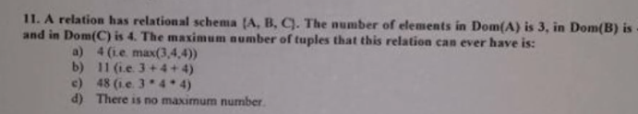

Raspuns: d) Nu exista un numar maxim

-----------------------------------------------------------------------------------------------------------------

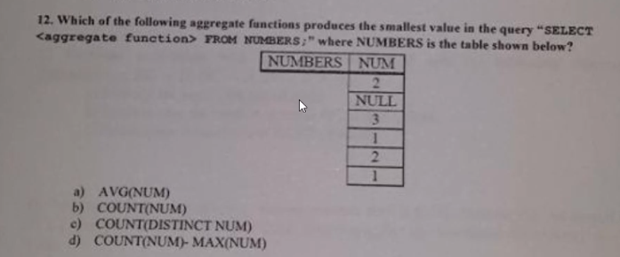

a = 1,8

b = 5

c = 3

d = 5-3 = 2

Raspuns: a)

-----------------------------------------------------------------------------------------------------------------

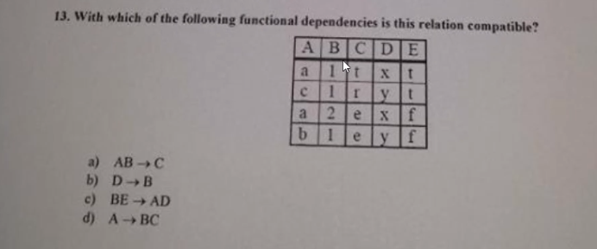

Raspuns: a)

**ACELASI INPUT -> ACELASI OUTPUT**

**INPUT diferit -> acelasi OUTPUT**

**!! CNP u lui Serju**

b) NU: x -> 1 si x->2

acelasi INPUT da valori diferite (**nu** e ok)

-----------------------------------------------------------------------------------------------------------------

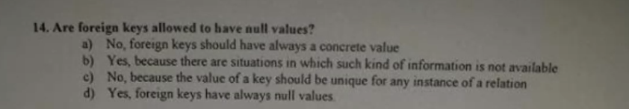

Raspuns: foreign key poate avea valori NULL

----------------------------------------------------------------------------------------------------------------

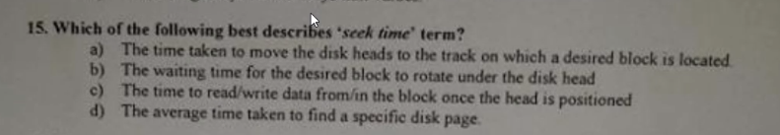seek time

Raspuns: a) ? sau d ?

---------------------------------------------------------------------------------------------------------------

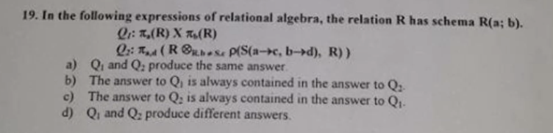

Q1 si Q2

Q1 : nr randuri: R^2, tabela cu 2 coloane (a si b)

Q2 : S.c = R.a si S.d = R.b

Raspuns: Q2 inclus in Q1

-------------------------------------------------------------------------------------------------------

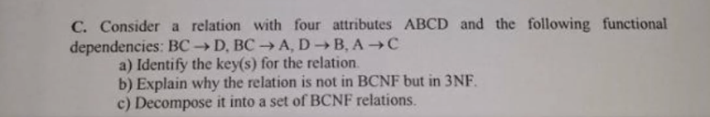

BCNF:

BC -> D ===> BC -> AD

BC -> A

D -> B

A -> C

a) BC, AD

c) D -> B ==> R1 = R \ {B} = {ACD} U {DB}

A -> C ==> R2 = R1 \ {C} = {AD} U {DB} U {AC}

R = {A -> D, D -> B, A -> C}

-----------------------------------------------------------------------------------------------------------------

ENGLEZA <https://drive.google.com/drive/folders/1024cVpjFnEmLSFCheWFrAIckxPo3I61Y?fbclid=IwAR15qQA5GL1U3k_BBwNKMsBNdp35nLHYm1EHiMTc3BEY1OAMAkaCsoRVMr8>

---------------------------------------------------------------------------------------------------------------

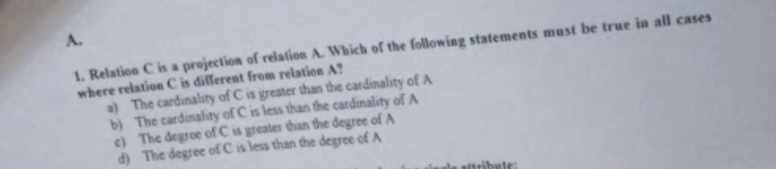

Raspuns: d) cardinal C < cardinal A

-----------------------------------------------------------------------------------------------------------------



Raspuns:a)

-----------------------------------------------------------------------------------------------------------------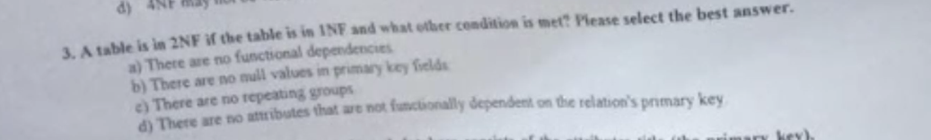

Raspuns: d

-----------------------------------------------------------------------------------------------------------------

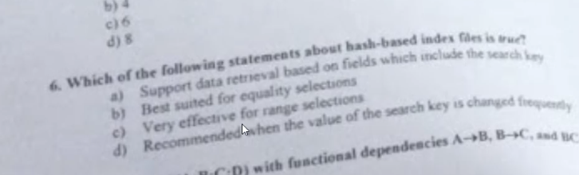

tabela hash

Raspuns: c ?

-----------------------------------------------------------------------------------------------------------------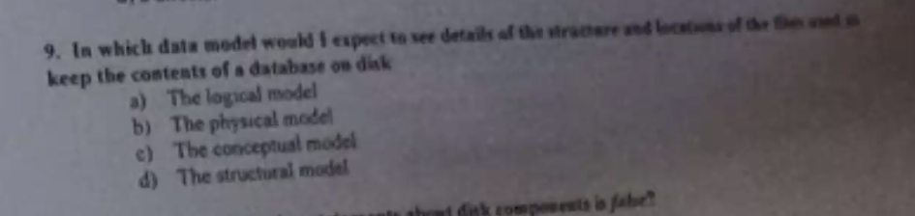

R: b) model fizic

-----------------------------------------------------------------------------------------------------------------

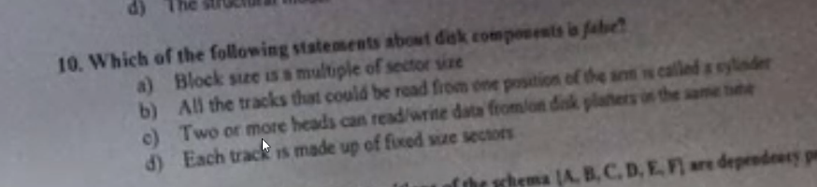

R: Disk componente

1. sigur e ADEVARAT

-----------------------------------------------------------------------------------------------------------------

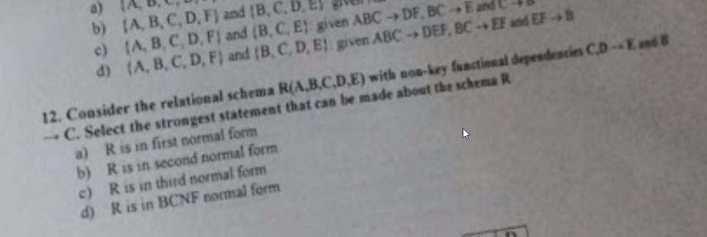

R: a)

-----------------------------------------------------------------------------------------------------------------

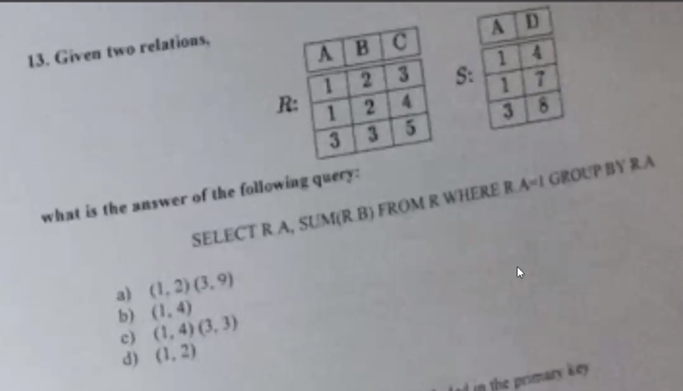

R: b)

-----------------------------------------------------------------------------------------------------------------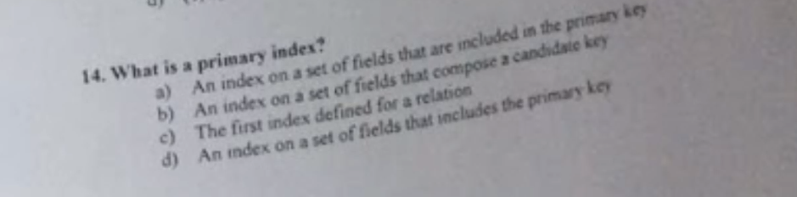

**index prim - face parte din cheia primara**

**index ne prim - nu face parte din cheie**

**R: a)**

**-----------------------------------------------------------------------------------------------------------------**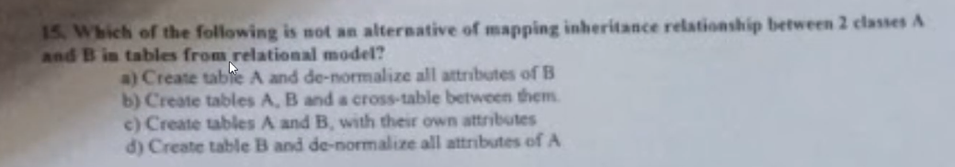

**R: b)**

**-----------------------------------------------------------------------------------------------------------------**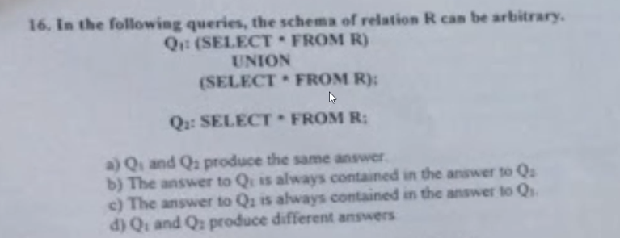

Q1 si Q2

**R: a) acelasi raspuns**

The UNION operator selects only distinct values by default. To allow duplicate values, use UNION ALL

------------------------------------------------------------------------------

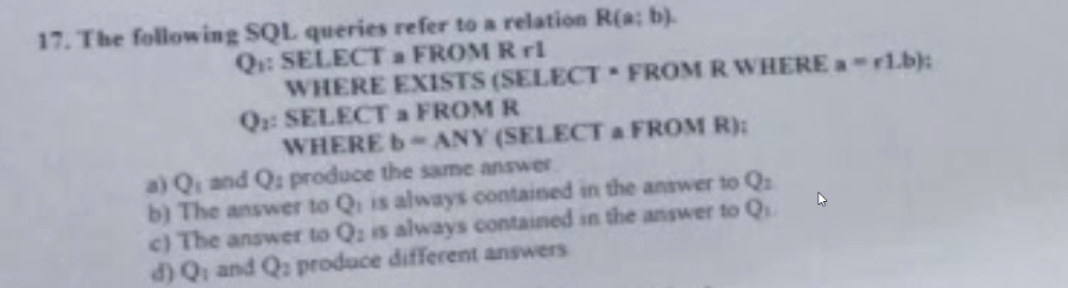

Q1 si Q2

Exists , ANY

R: a)

-------------------------------------------------------------------------------

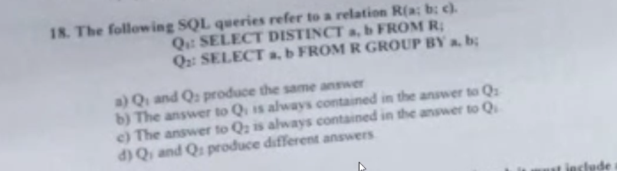

Q1 si Q2

DISTINCT , GROUP BY

R: a

----------------------------------------------------------------------

SCRIPT

create table R(

a int,

b int,

c int

);

create table S(

a int,

d int

);

---------------------------------------------------------------------

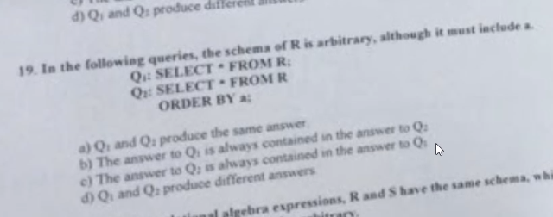

Q1 si Q2

R: a

-------------------------------------------------------------------------------

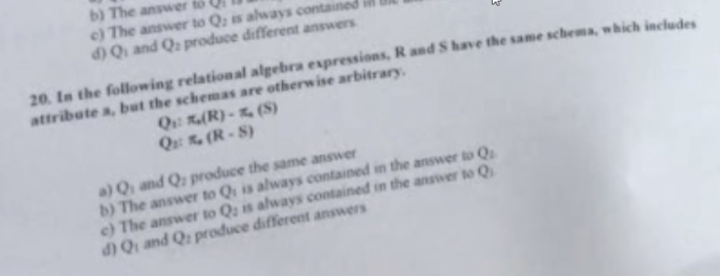

Q1 si Q2

R: d)

-------------------------------------------------------------------------------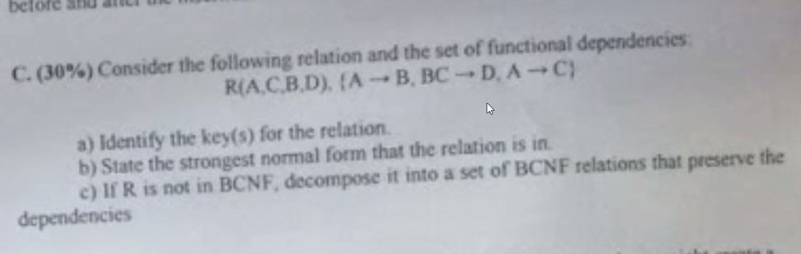

1. key: A
2. 2NF
3. A->B, A->C⇔ A->BC

BC->D nu e in BCNF

descompunem in {ABC},{BCD}

A->BC, BC->D